Knowledge Engineering And Data Science
LAB
1.Grade Analysis Using Pie chart and Graph
Aim
To develop a Python program using suitable data structures and Matplotlib to analyze the distribution of students across different grades by drawing a pie chart and bar chart, identifying the maximum and minimum grades, and calculating the combined percentage of students who secured A and S grades.
Software Required
- Python 3.x
- Matplotlib library
- Install Matplotlib using:
Procedure / Algorithm
- Store the grades and corresponding number of students in suitable data structures such as lists.
- Calculate the total number of students.
- Calculate the percentage of students for each grade.
- Draw a pie chart to represent the percentage distribution of students.
- Display grade labels and percentage values on the pie chart.
- Add a suitable title and legend to the pie chart.
- Draw a bar chart to compare the number of students in each grade.
- Label the X-axis as Grades and the Y-axis as Number of Students.
- Display the exact number of students above each bar.
- Add a suitable title and legend to the bar chart.
- Find the grade with the maximum number of students.
- Find the grade with the minimum number of students.
- Calculate the combined percentage of students who secured grades A and S.
- Display the results.
Program

import matplotlib.pyplot as plt
# 1. Store grades and corresponding number of students
grades = ['F', 'E', 'D', 'C', 'B', 'A', 'S']
students = [3, 4, 5, 8, 9, 7, 4]
total_students = sum(students)
# Calculate percentage distribution
percentages = [(count / total_students) * 100 for count in students]

# 2 & 3. Draw pie chart with grade labels and percentage values
plt.figure(figsize=(8, 6))

plt.pie(
students,
labels=grades,
autopct='%1.1f%%',
startangle=90
)
plt.title('Percentage Distribution of Students by Grade')
plt.legend(grades, title='Grades')
plt.show()
# 4, 5 & 6. Draw bar chart
plt.figure(figsize=(8, 6))

bars = plt.bar(grades, students)

plt.xlabel('Grades')
plt.ylabel('Number of Students')
plt.title('Number of Students in Each Grade')
plt.legend(['Students'])

# Display exact number of students above each bar
for bar, count in zip(bars, students):
plt.text(
bar.get_x() + bar.get_width() / 2,
bar.get_height() + 0.1,
str(count),
ha='center',
va='bottom'
)

plt.show()

# 8. Identify maximum and minimum grades
max_students = max(students)
min_students = min(students)

max_grade = grades[students.index(max_students)]
min_grade = grades[students.index(min_students)]

print("Grade with maximum number of students:", max_grade)
print("Number of students:", max_students)

print("Grade with minimum number of students:", min_grade)
print("Number of students:", min_students)

# 9. Calculate percentage of students with A and S combined
A_students = students[grades.index('A')]
S_students = students[grades.index('S')]

A_S_percentage = ((A_students + S_students) / total_students) * 100

print("Percentage of students who secured A and S combined:",
f"{A_S_percentage:.2f}%")

OutPut:
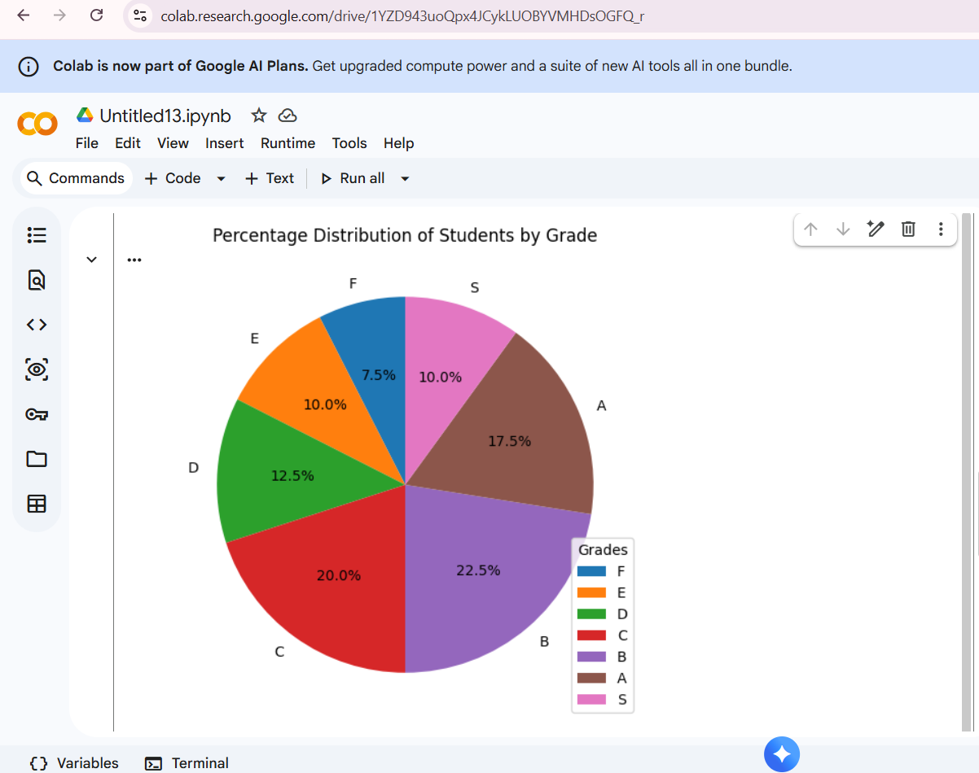

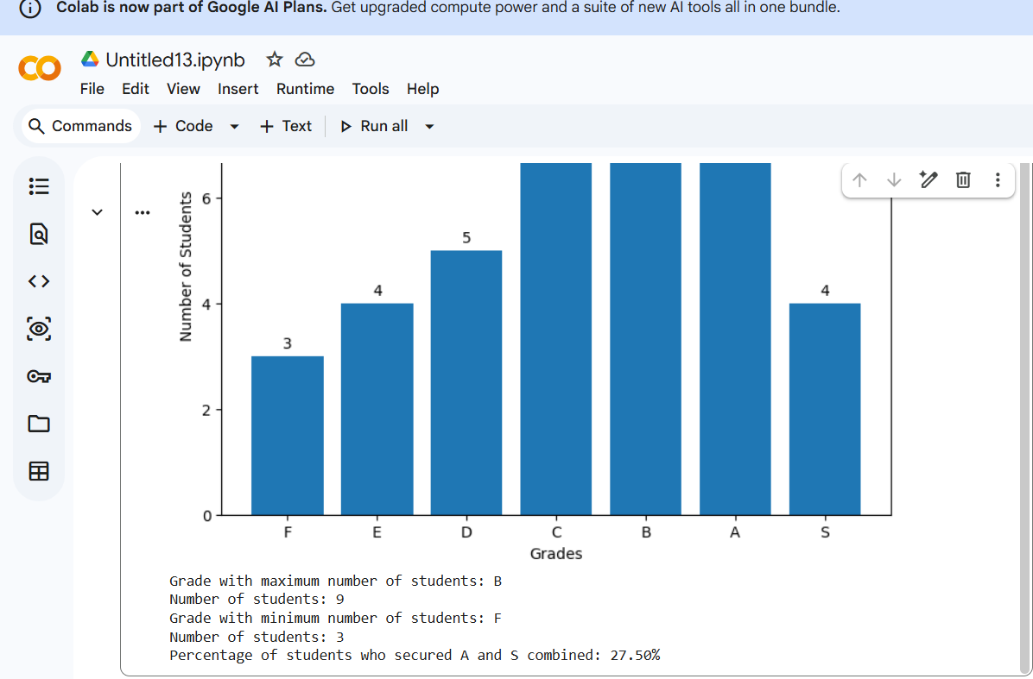

Result
The Python program successfully analyzed the student grade distribution using pie and bar charts, identified B as the grade with the maximum number of students and F as the grade with the minimum number of students, and calculated the combined percentage of students securing A and S as 27.50%
2. Semantic Network Using NetworkX
Aim
To represent concepts and labeled relationships as a directed semantic network.
Software Required
- Python 3.x
- NetworkX library
- Install using:
pip install networkx
Procedure / Algorithm
- Create a directed graph using DiGraph().
- Add concepts as nodes implicitly through edges.
- Add labeled relationships between the concepts.
- Display each relationship using edges(data=True).
Program
import networkx as nx

# Create a directed graph
G = nx.DiGraph()

# Add concepts and labeled relationships
G.add_edge("Dog", "Mammal", relation="is-a")
G.add_edge("Mammal", "Animal", relation="is-a")
G.add_edge("Dog", "Tommy", relation="has-instance")

# Display relationships
print("Semantic Network Relationships:")

for source, target, data in G.edges(data=True):
print(source, "--", data["relation"], "-->", target)

OUTPUT:
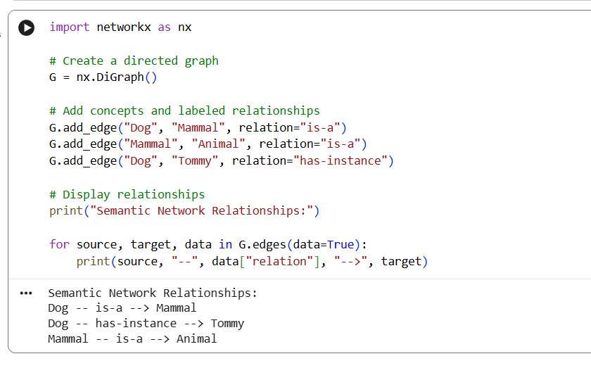

Result
The semantic network was successfully created using NetworkX, representing concepts and their labeled relationships.

3.Frame-Based Knowledge Representation
Aim
To represent an object as a frame containing slots and values.
Software Required
- Python 3.x
Procedure / Algorithm
- Create a dictionary to represent a frame.
- Use keys as slots and values as the corresponding slot values.
- Display the frame using a for loop.
Program
# Create a frame using a dictionary
vehicle = {
"class": "Vehicle",
"brand": "Toyota",
"fuel_type": "Petrol",
"wheels": 4,
"color": "White"
}

# Display the frame
print("Vehicle Frame")

for slot, value in vehicle.items():
print(slot, ":", value)

OUTPUT:
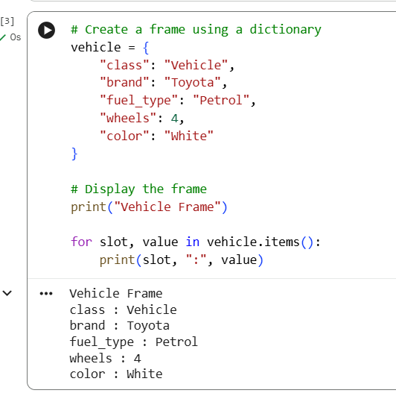

Result
The vehicle was successfully represented using a frame containing slots and their corresponding values.

